**UPDATE VM SERVERS AND CLIENT IP AND DNS ADDRESSES**

**DC SERVER**

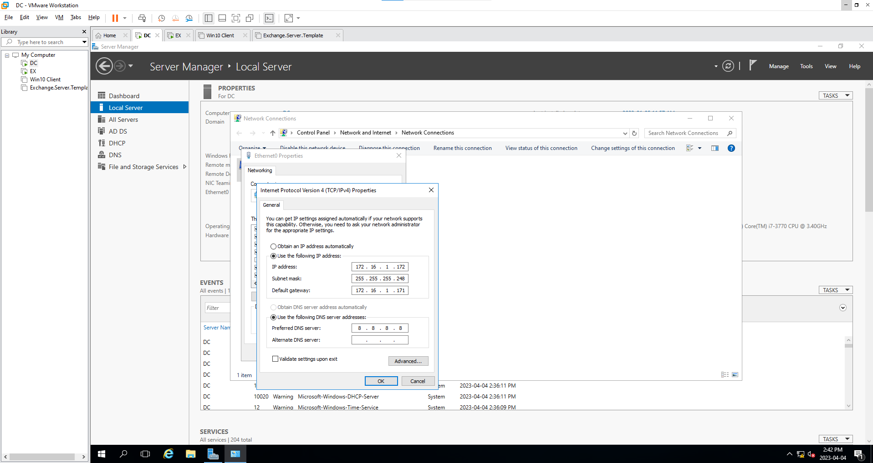

**EX SERVER**

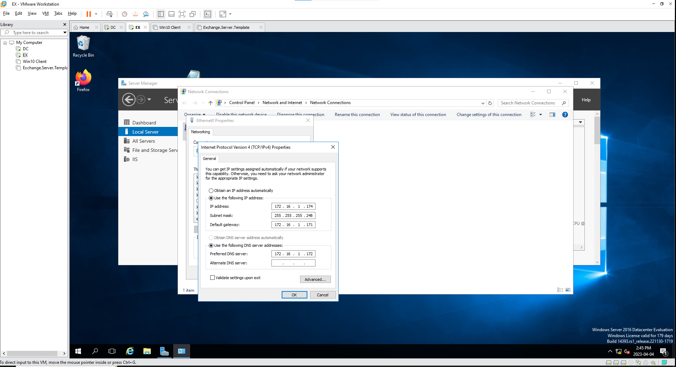

**Win10Client**

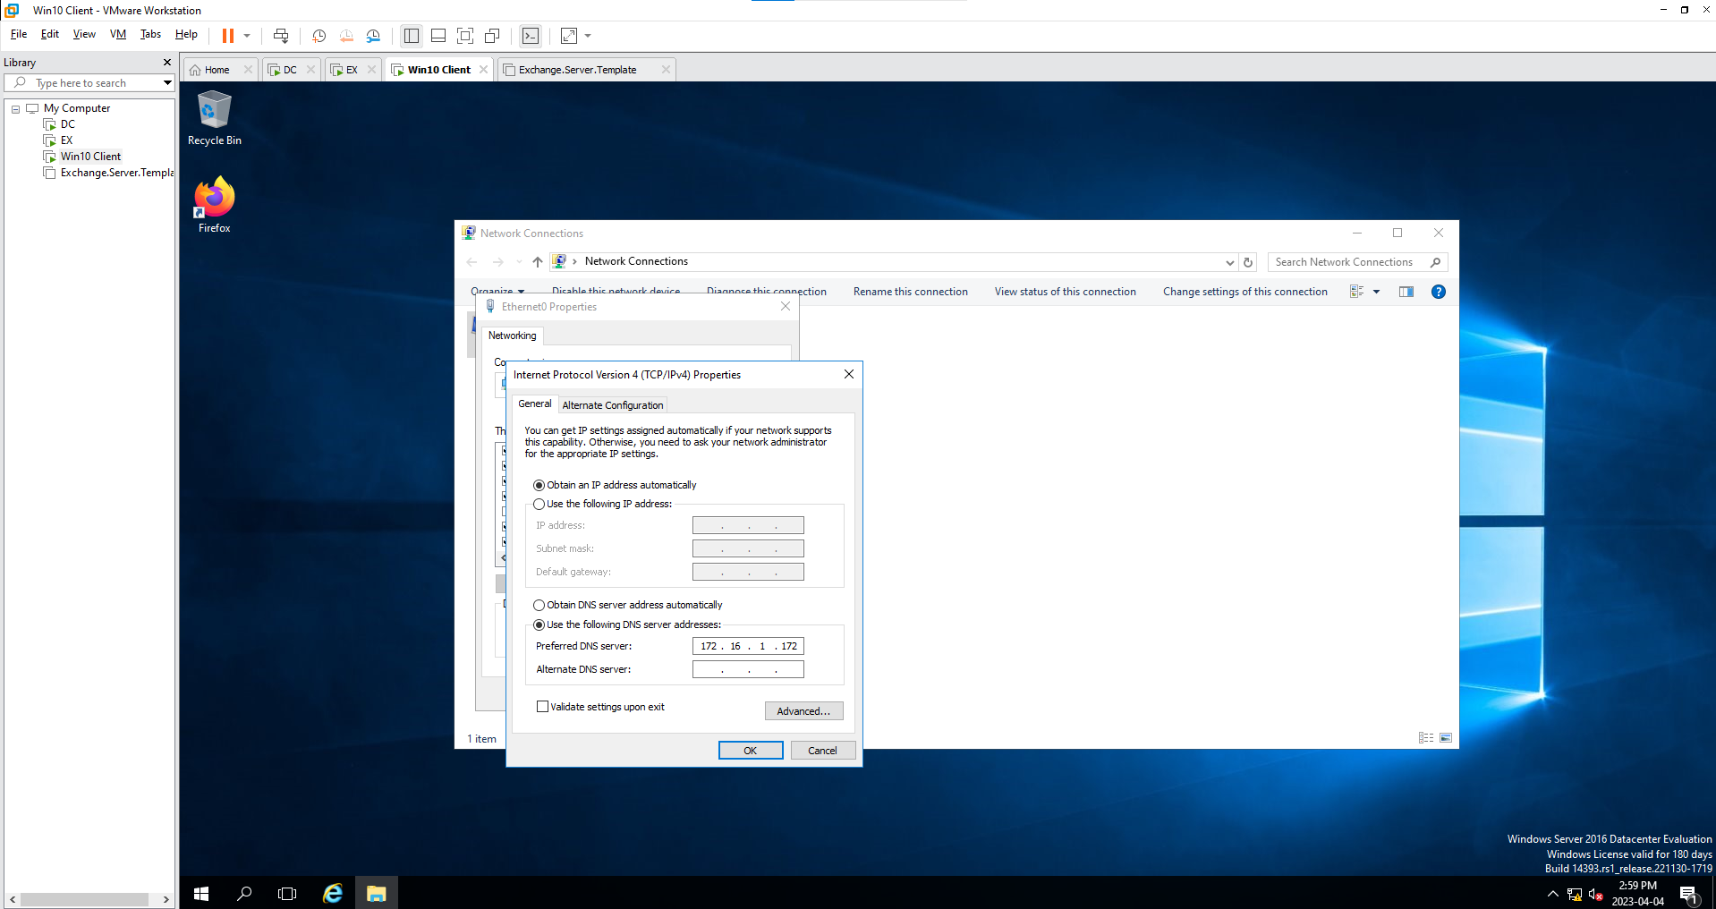

**UPDATE DNS MANAGER RECORD(A, MX, Autodiscover)**

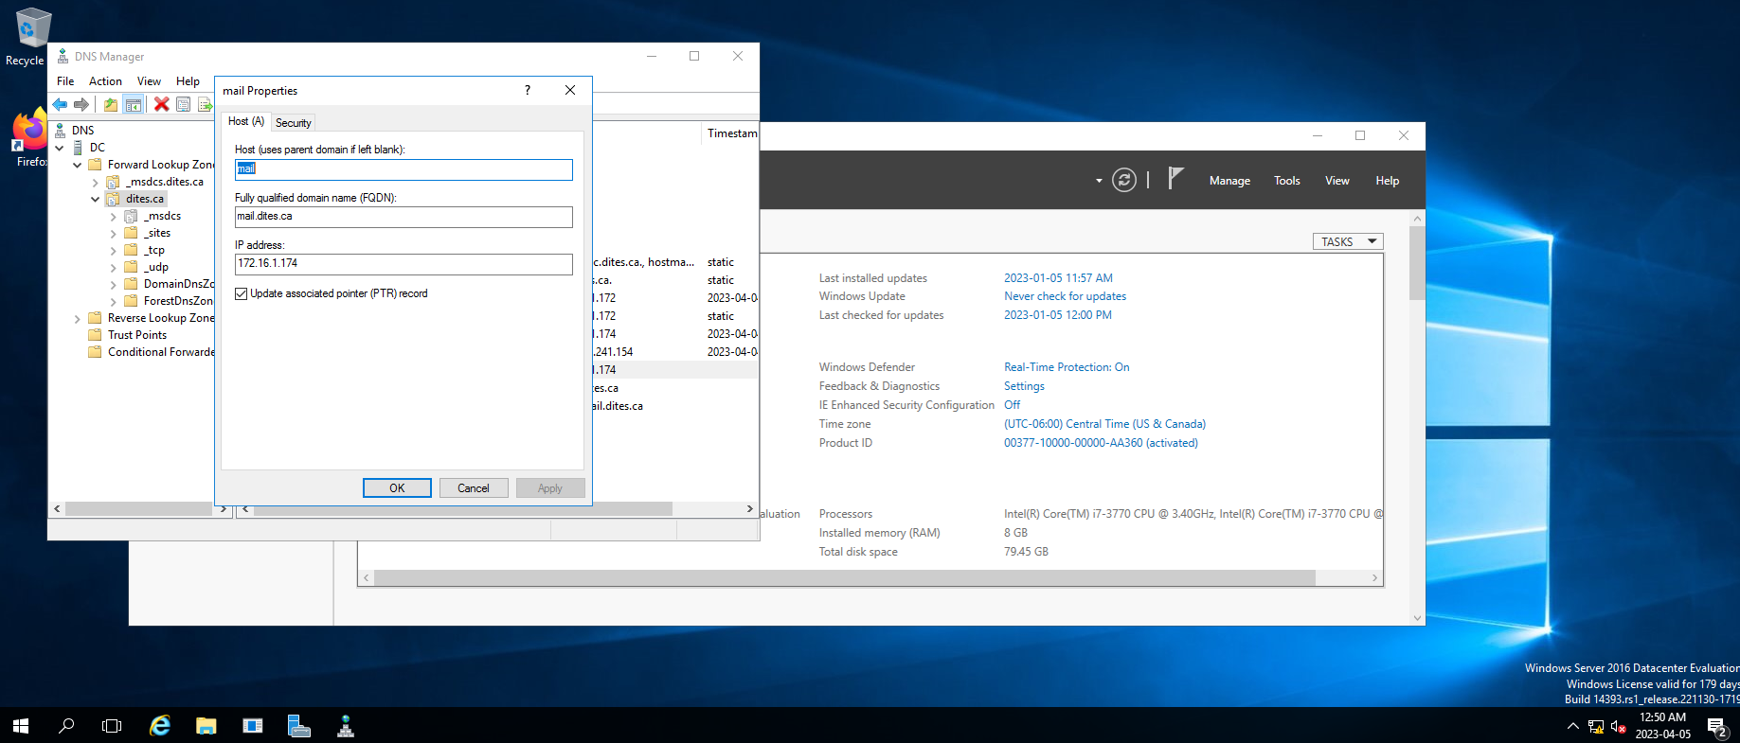

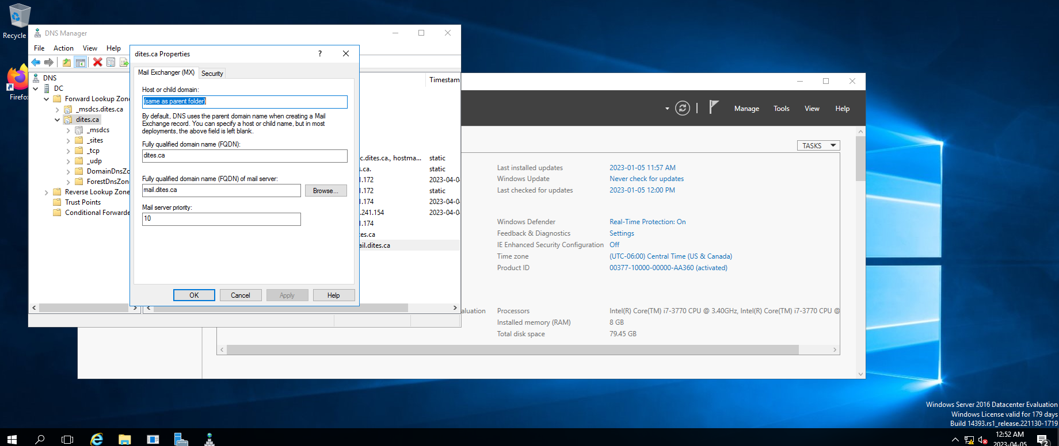

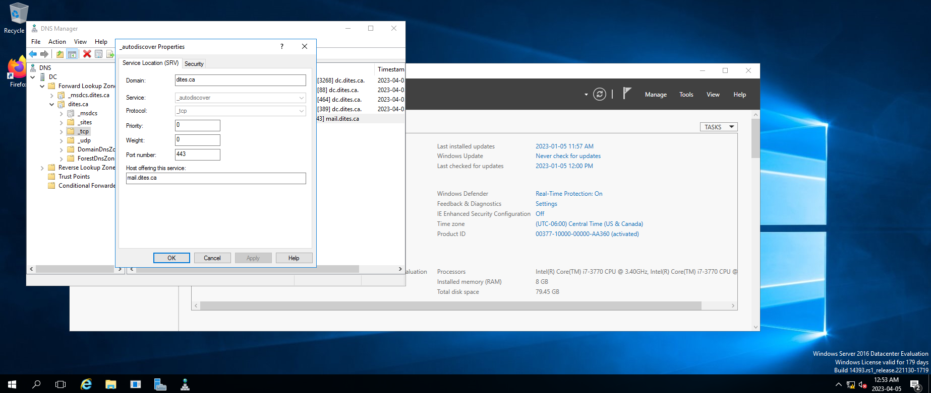

**ADDING DISK FOR STORAGE POOL**

**Adding three disks to creating storage pool for redundancy and availability. On the pool, we create two virtual disks for configuration storage(10Gb) and share folders(20Gb).**

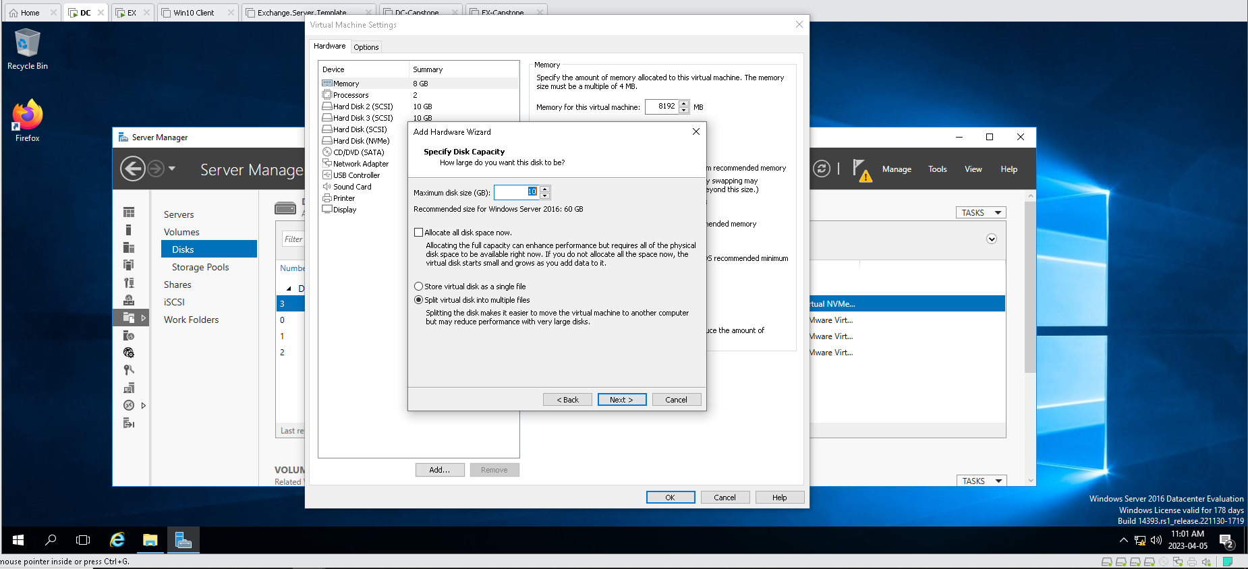

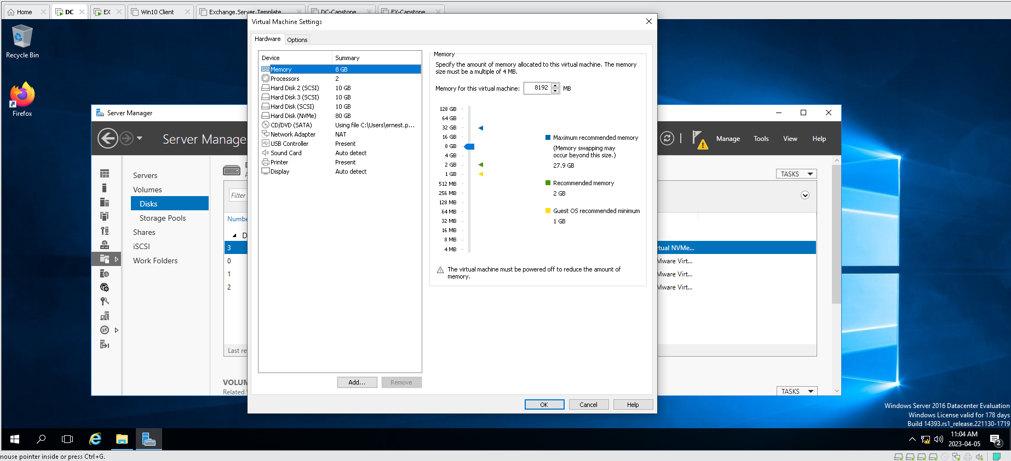

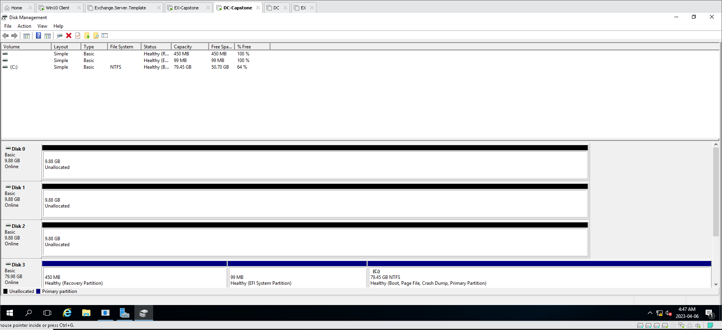

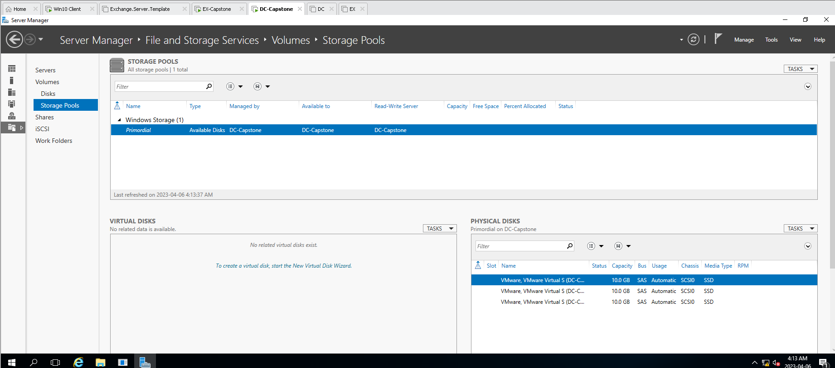

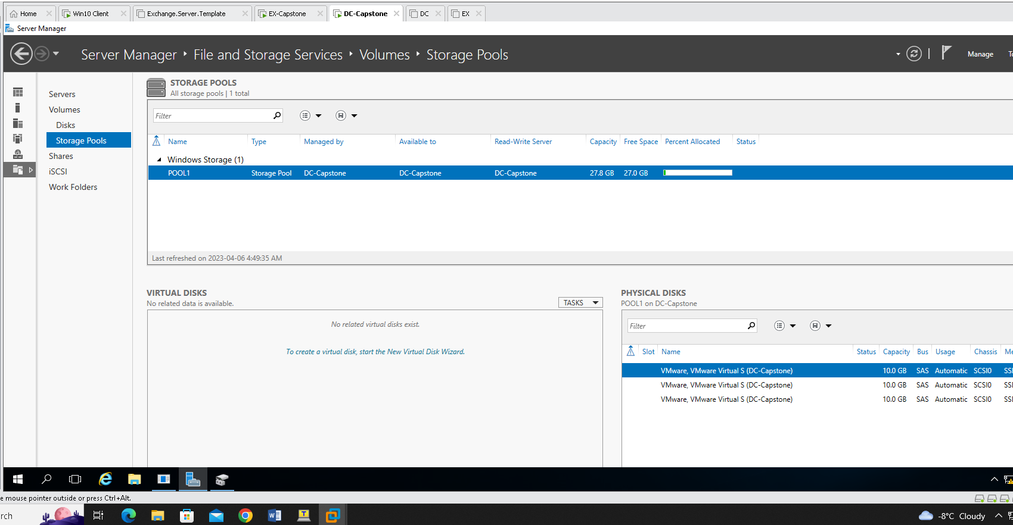

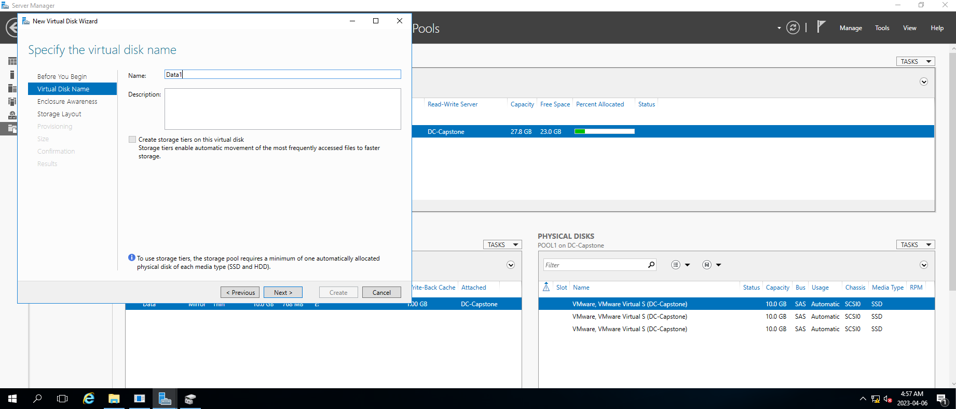

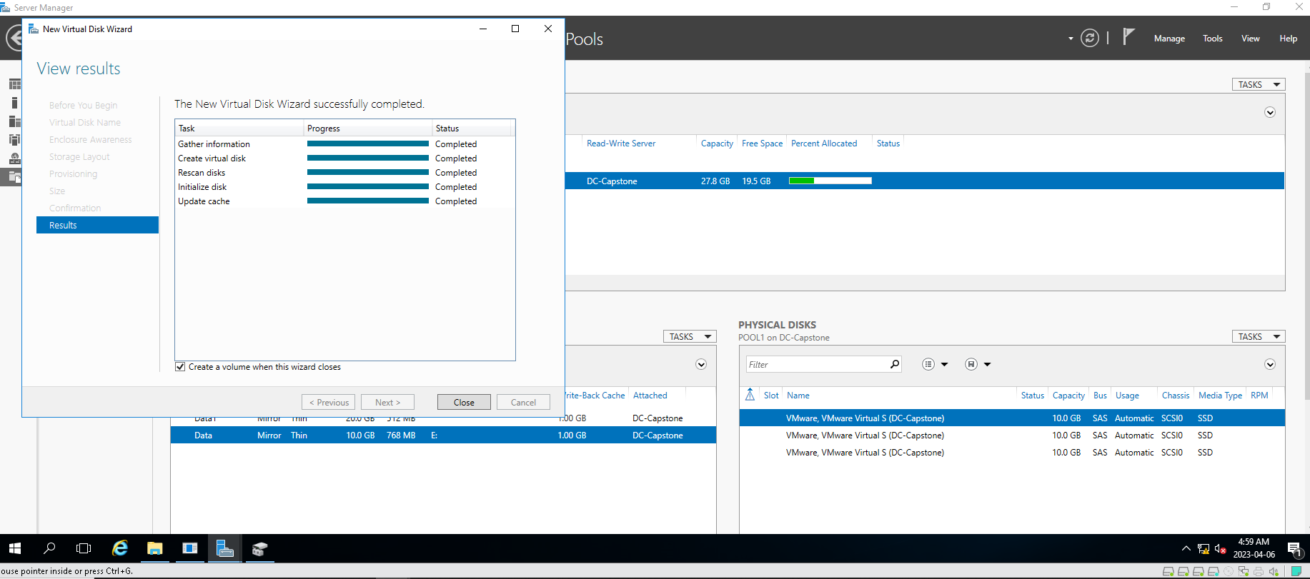

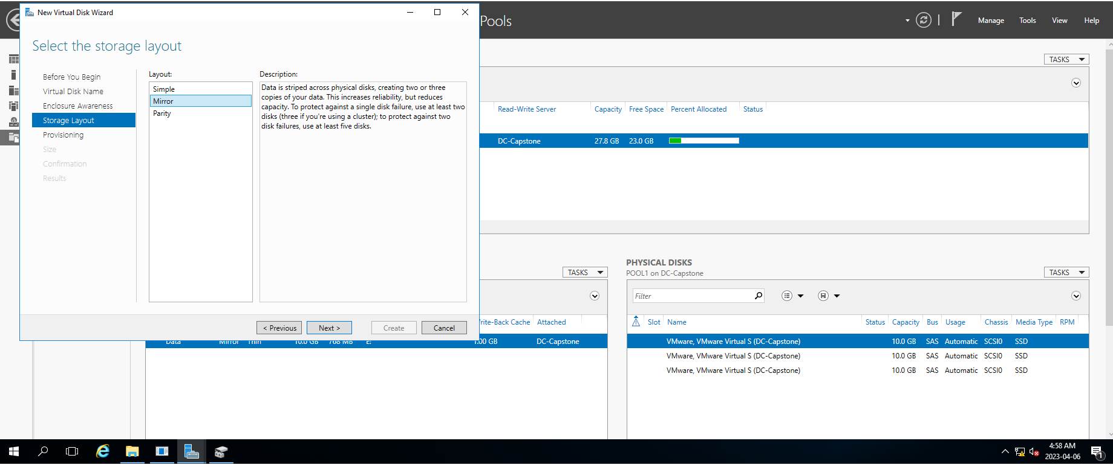

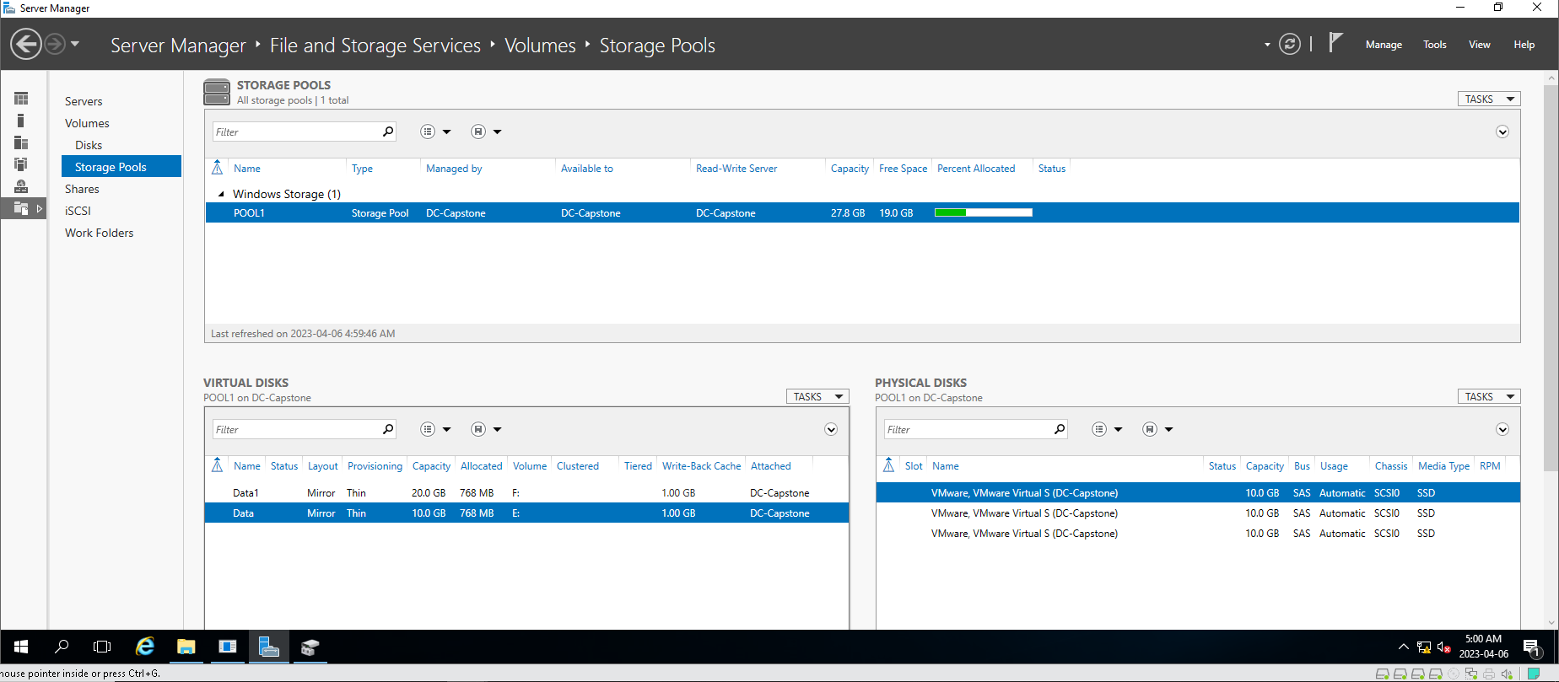

**ADD USERS ON OU BY IMPORT CSV**

**Add users on OU and create mailbox on the exchange server.**

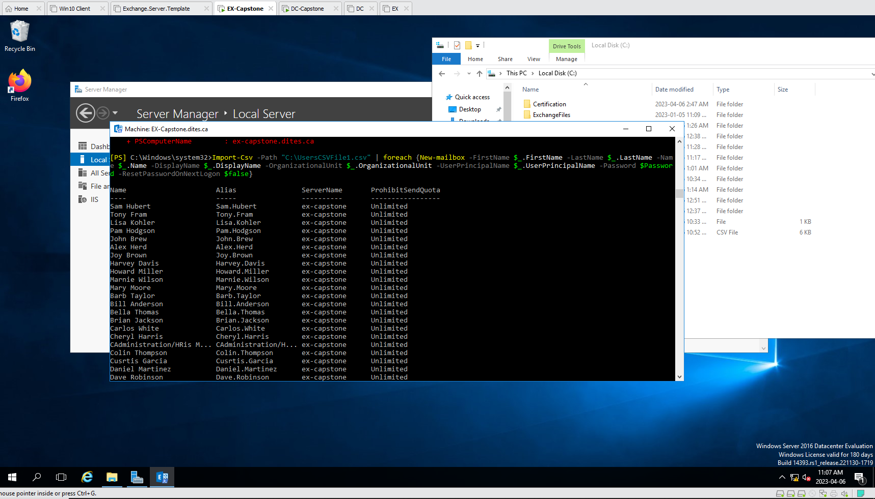

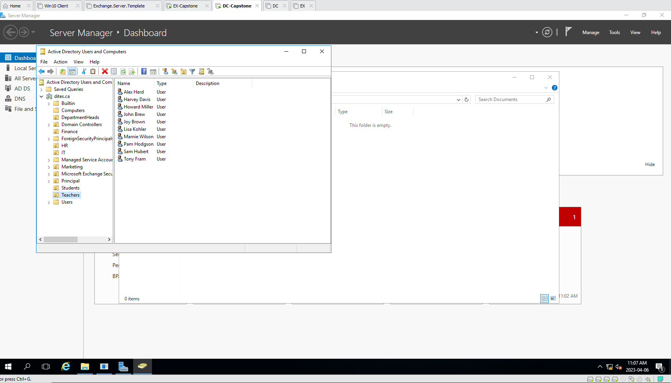

**CREATING SHARE FOLDERS AND PERMISSIONS**

**Creating departments share folders and set authorized groups and users permissions.**

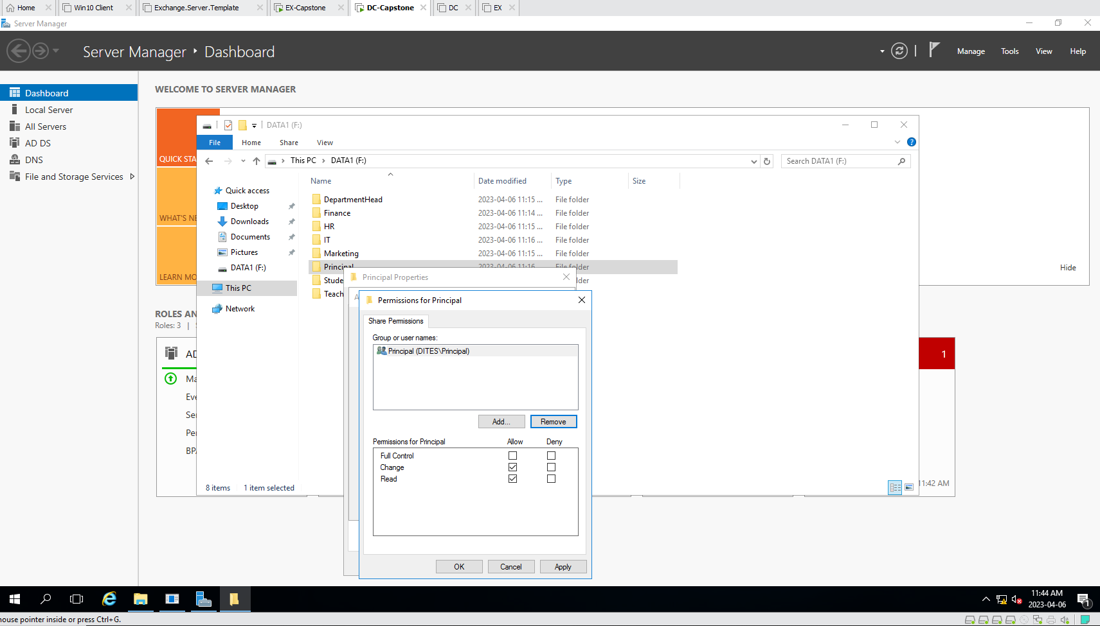

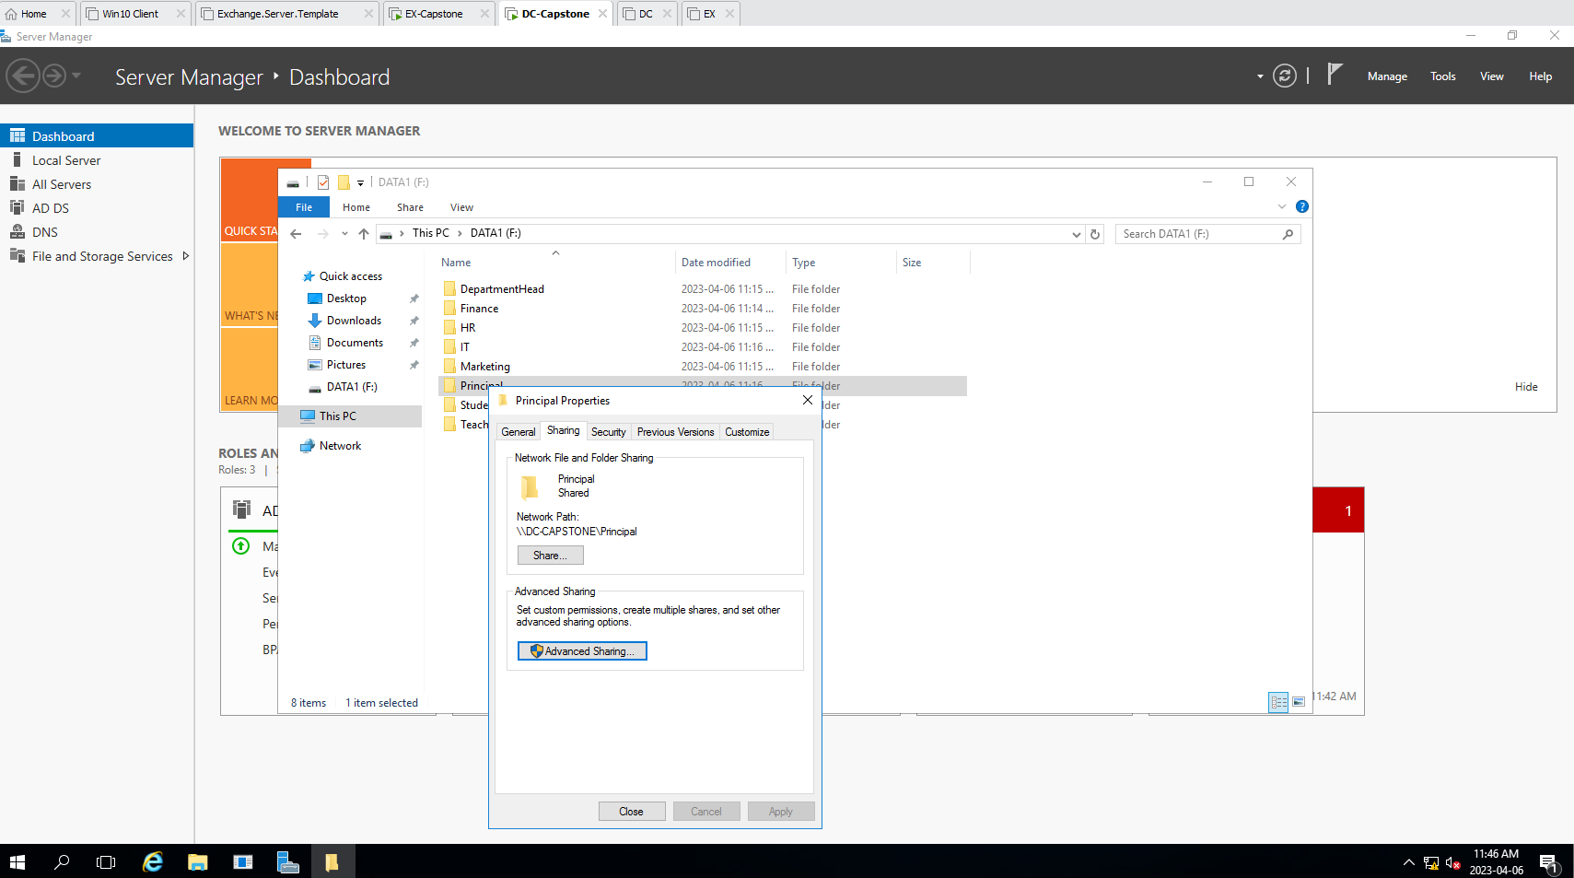

**DFS**

**Adding share folders for the users and giving folders permissions. The owner of the folder have an permission of read and modify, IT department have full permission, and head of the user folder have and read permission.**

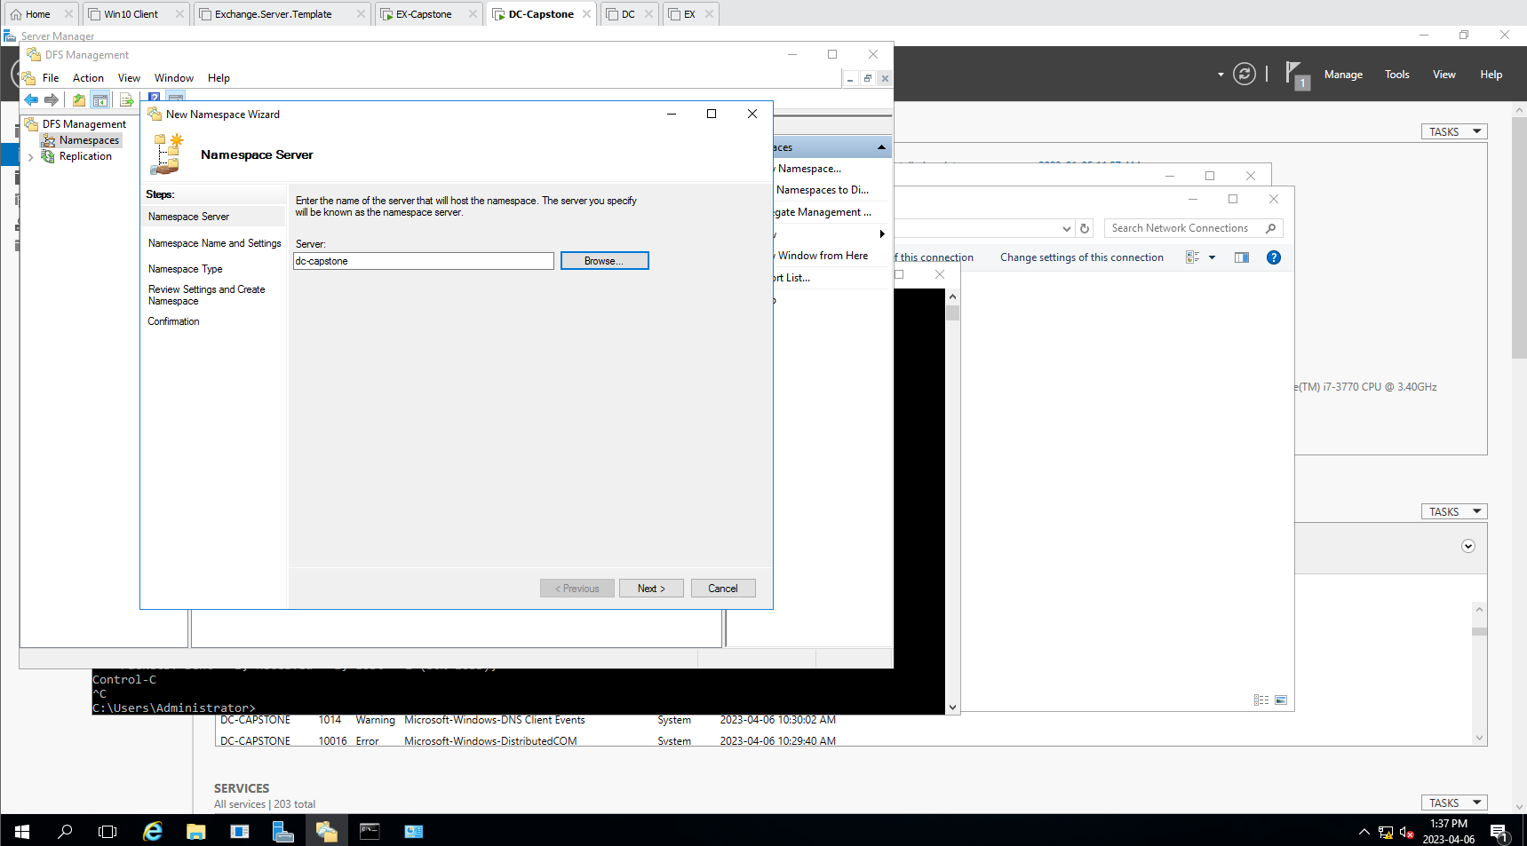

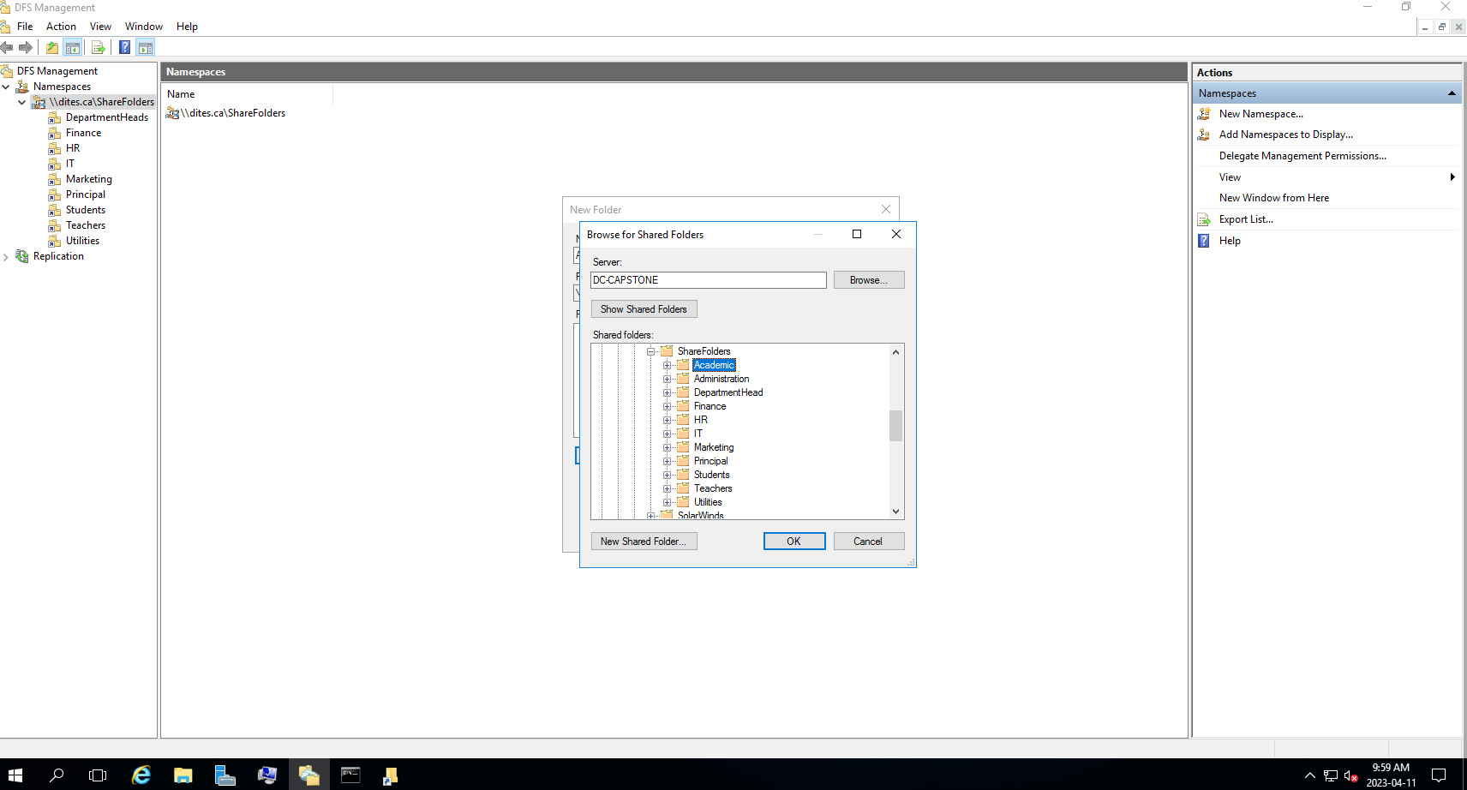

**Replicate the exchange database data to the DC server for backup and redundancy of the data.**

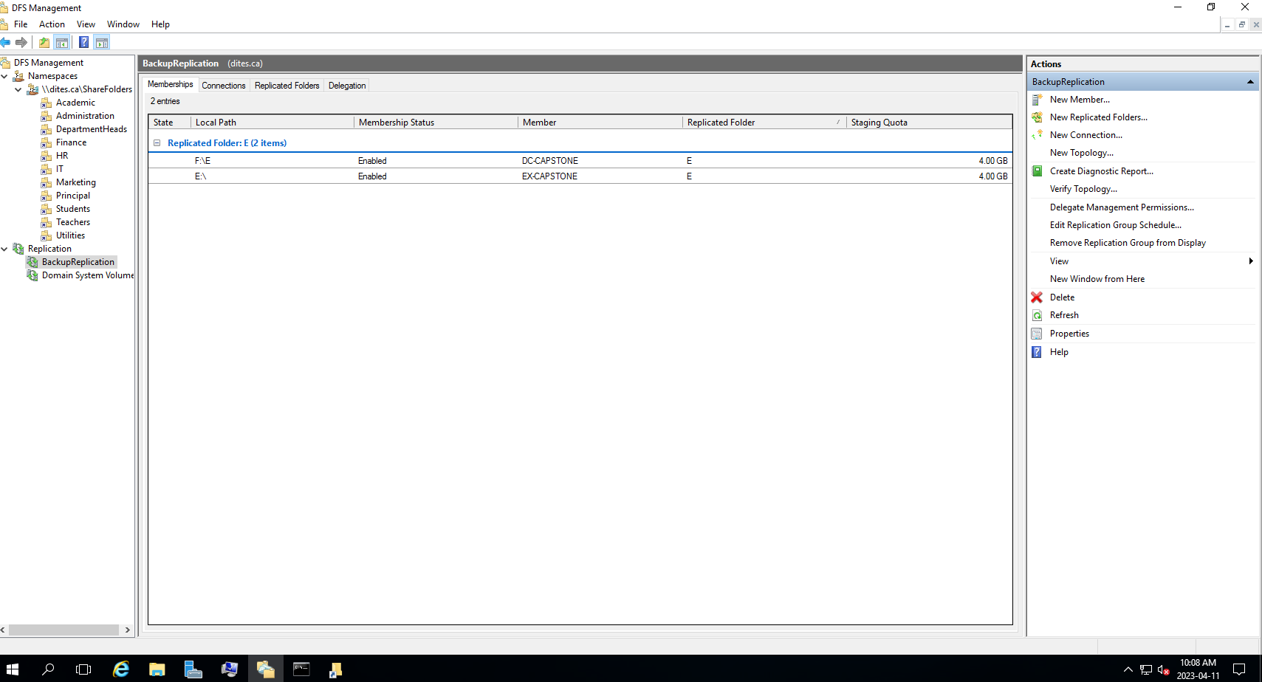

**Internet Information Services**

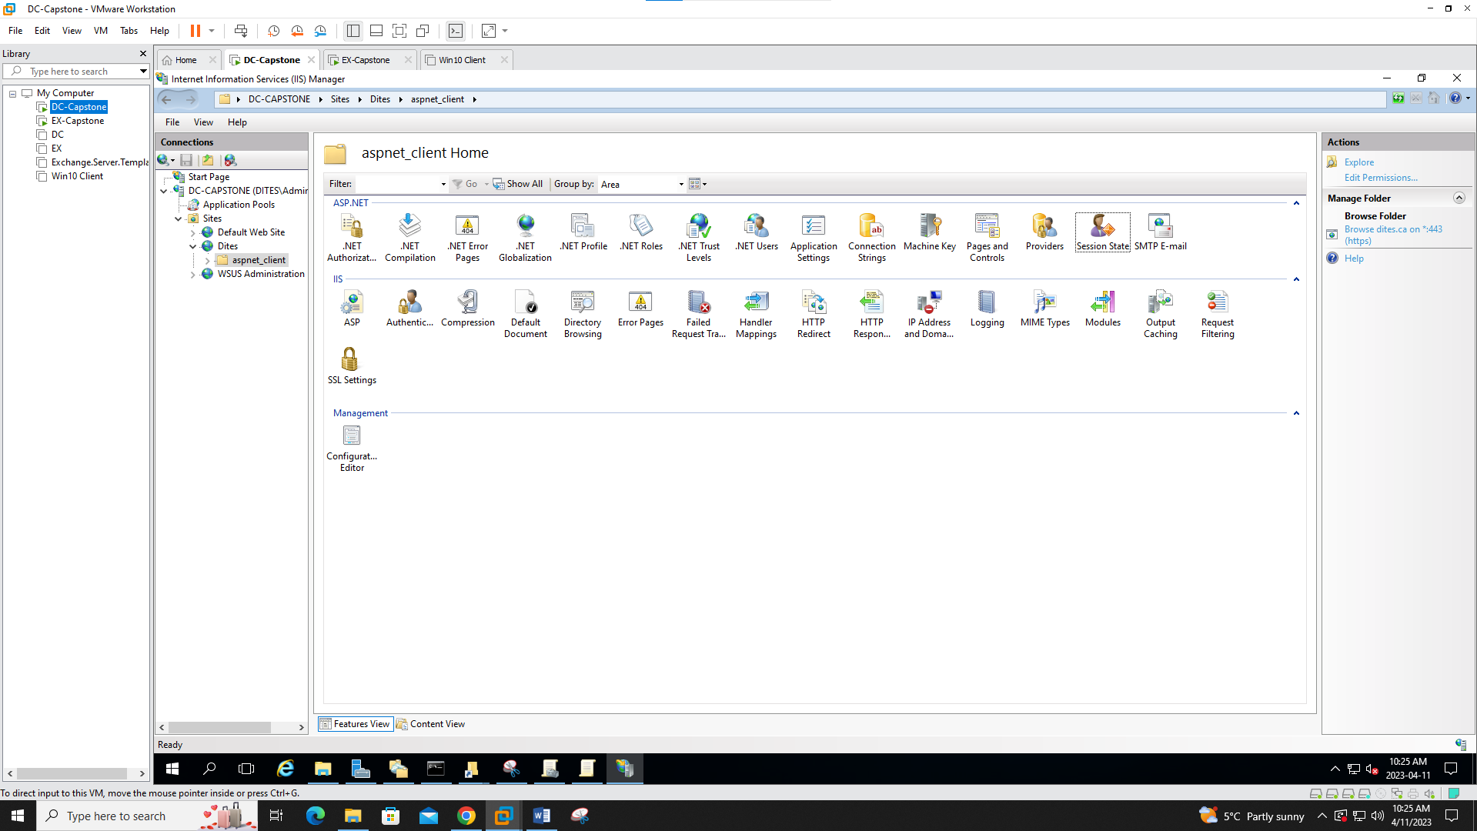

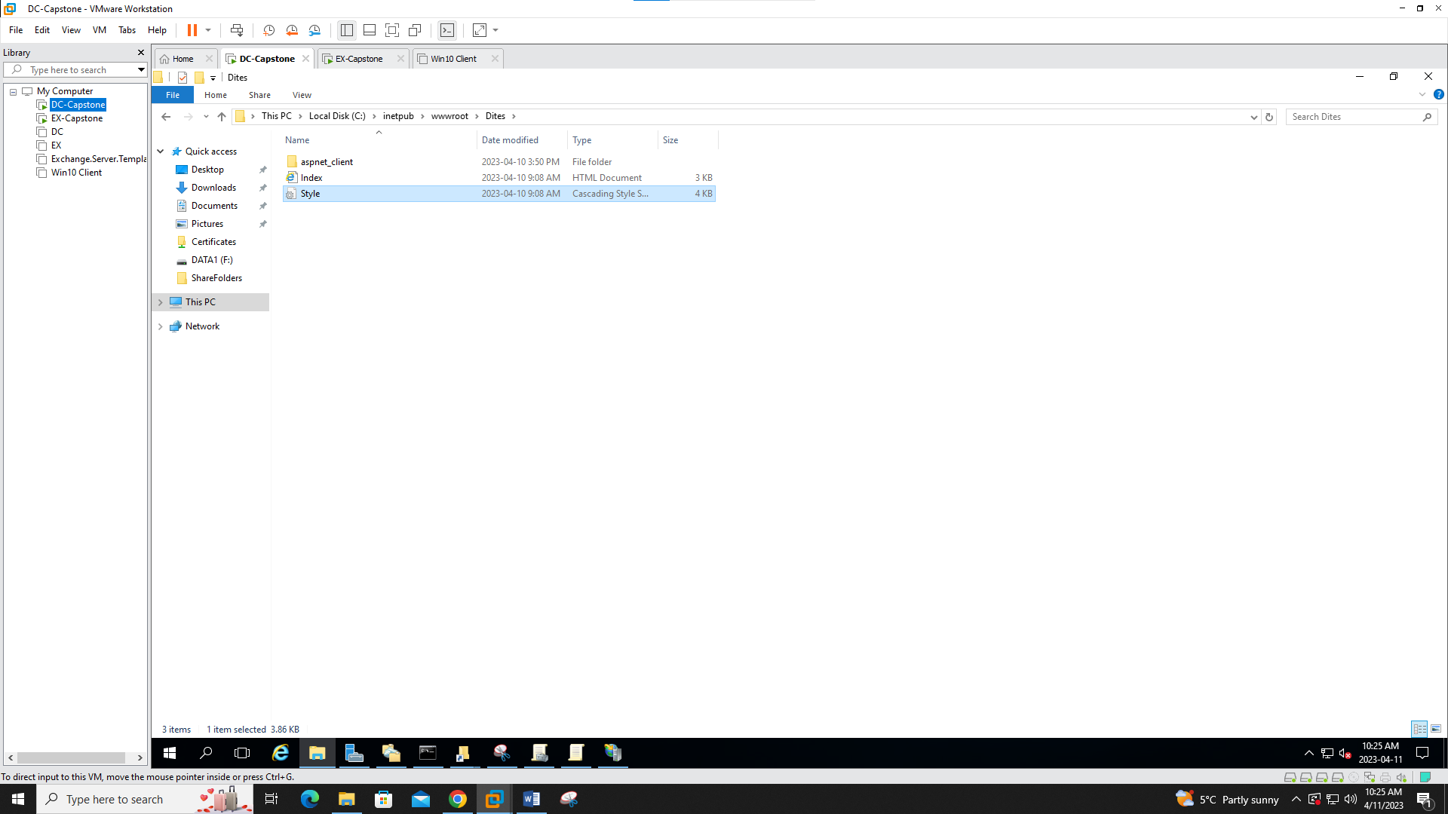

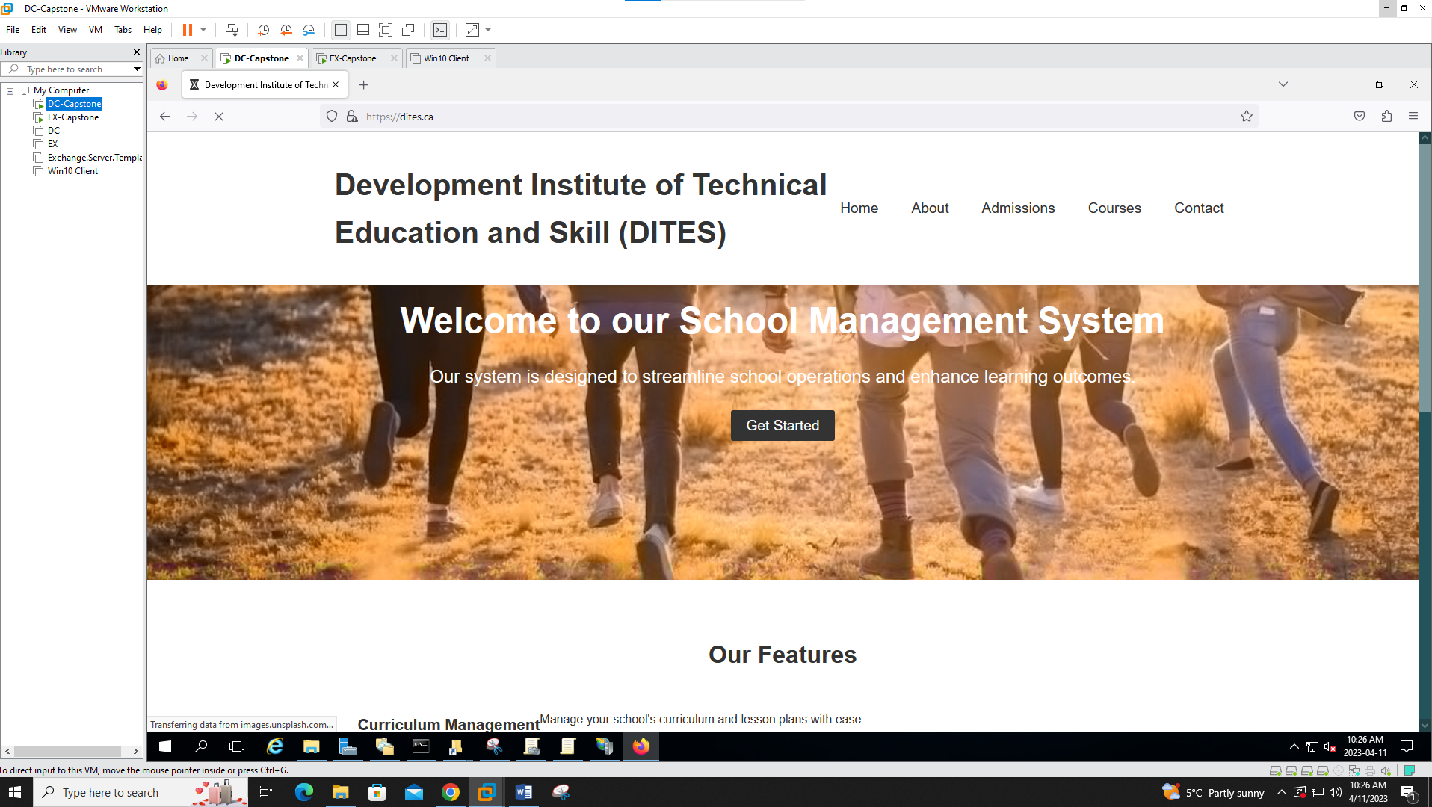

**Group Policy**

1. **Disable Control Panel**

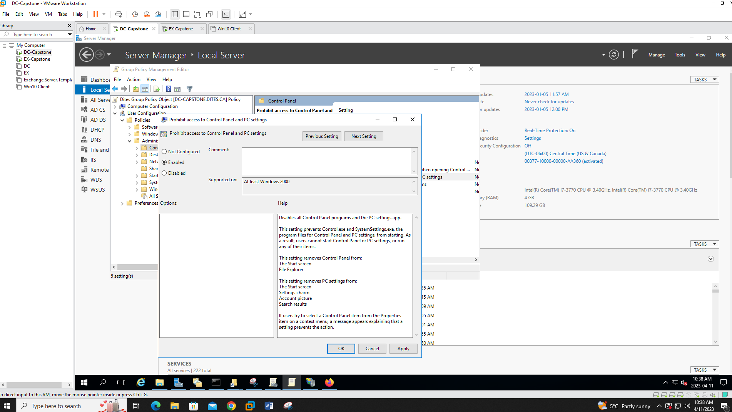

1. **Prevent windows from store LAN manager hash**

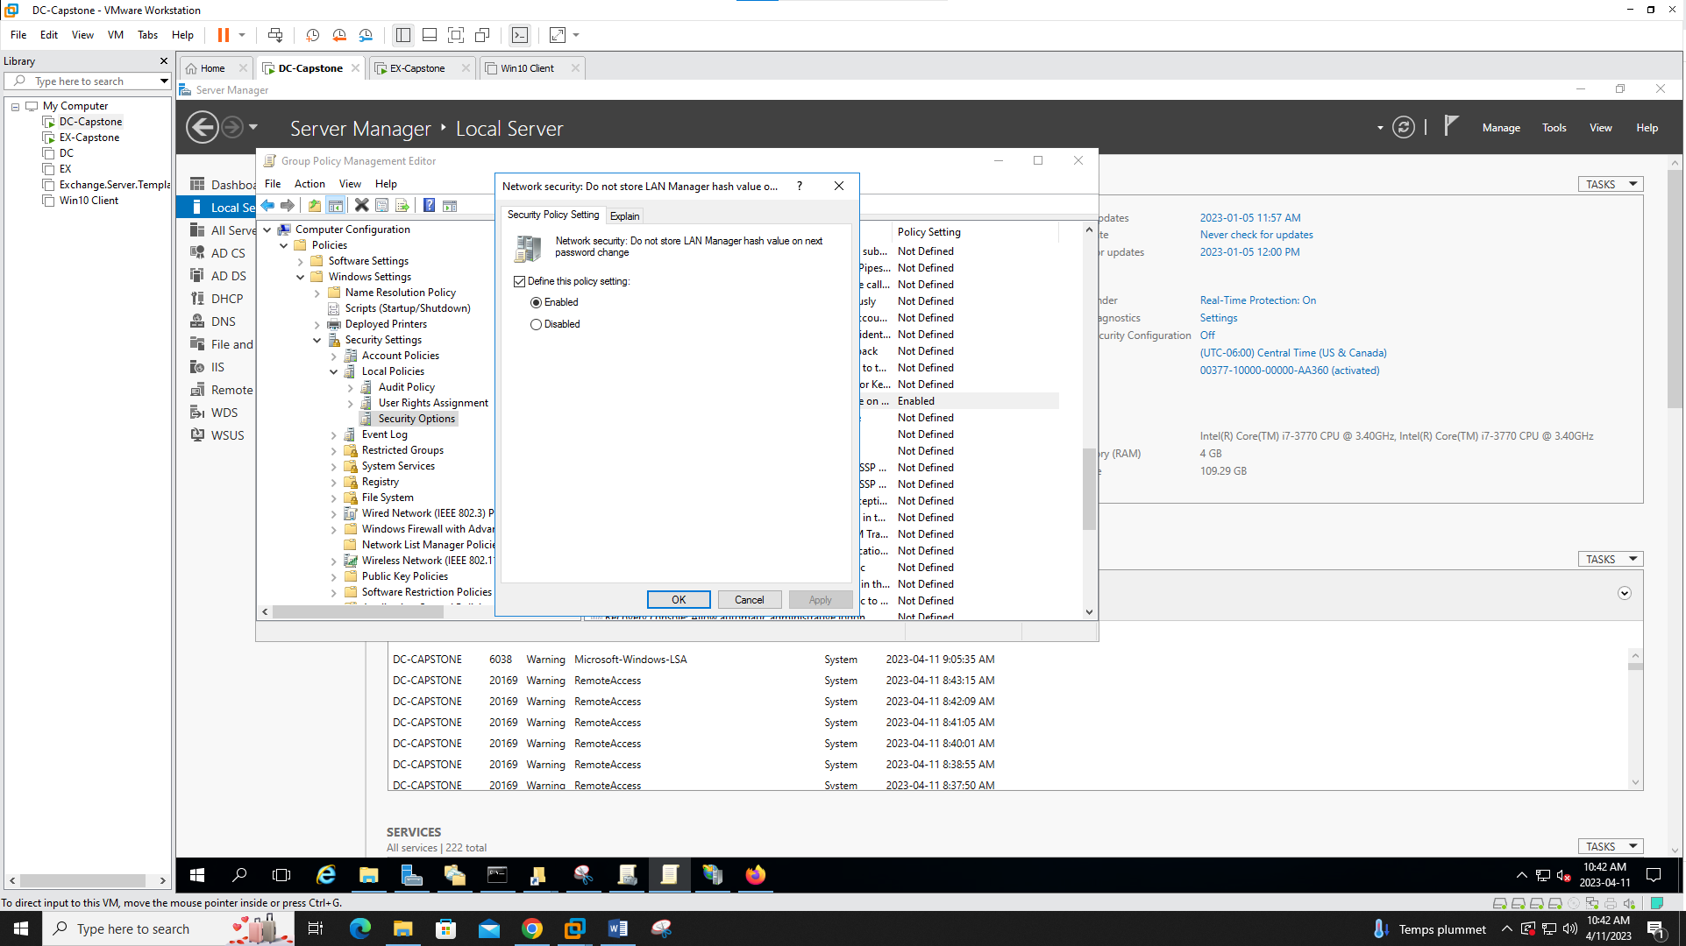

1. **Disable force system restart**

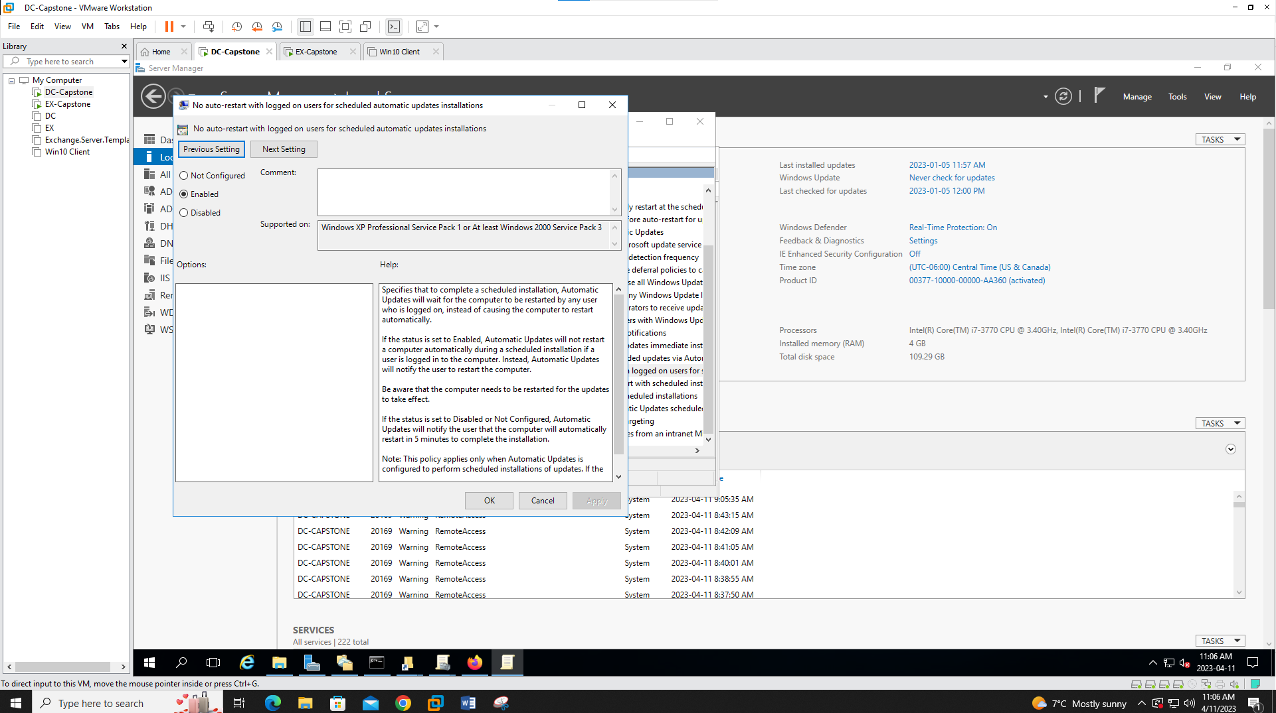

1. **Disable removable media storage**

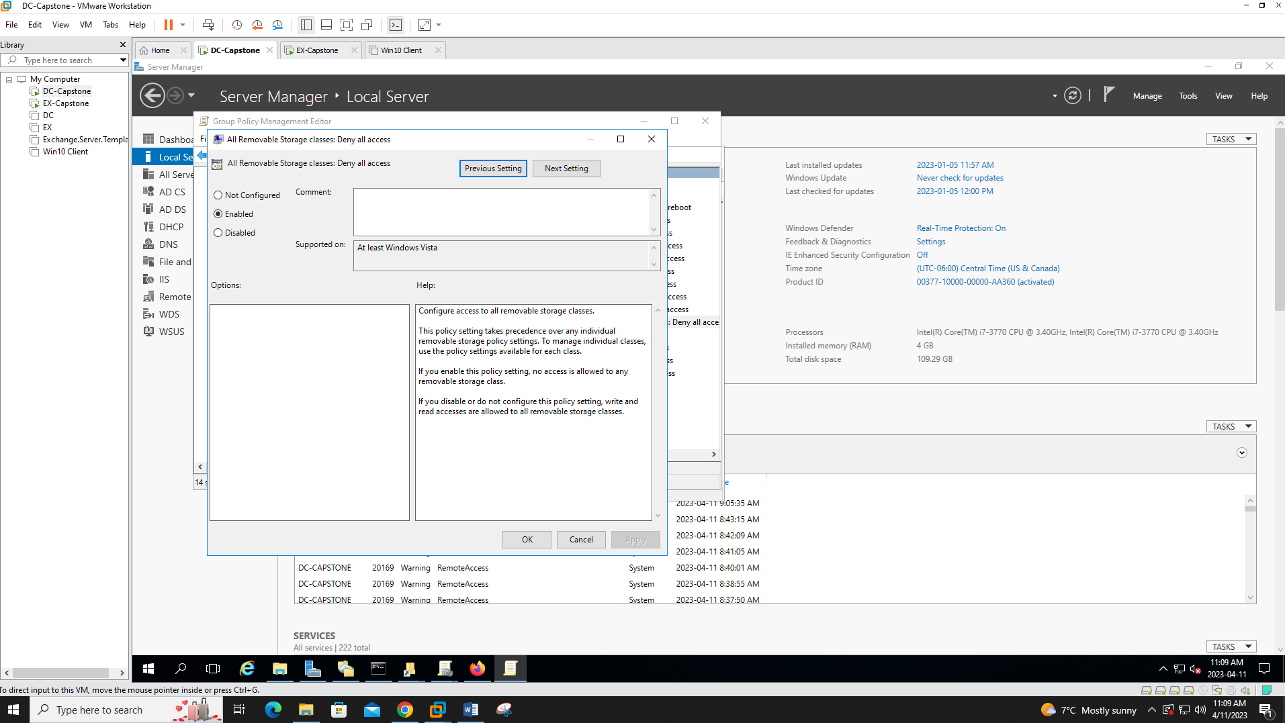

1. **Password minimum length and maximum age**

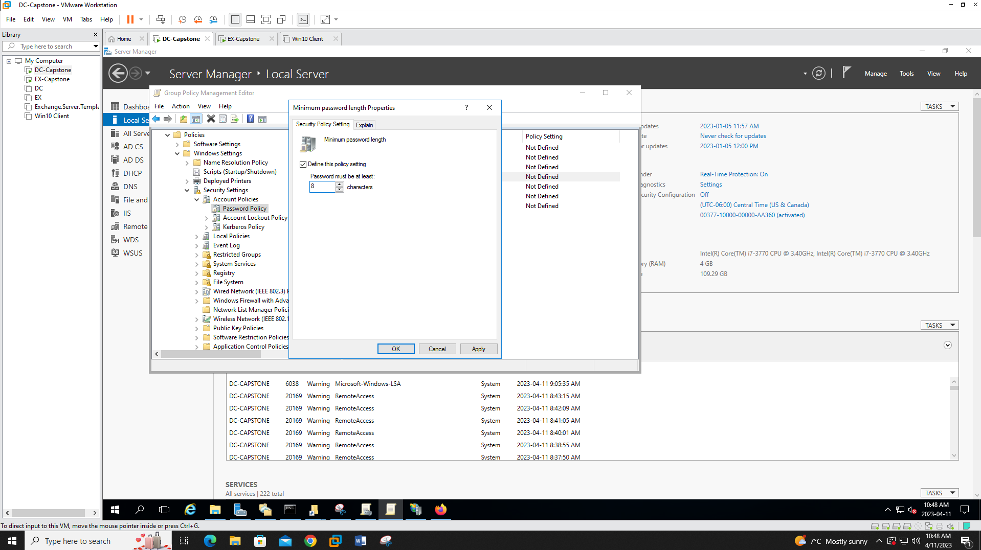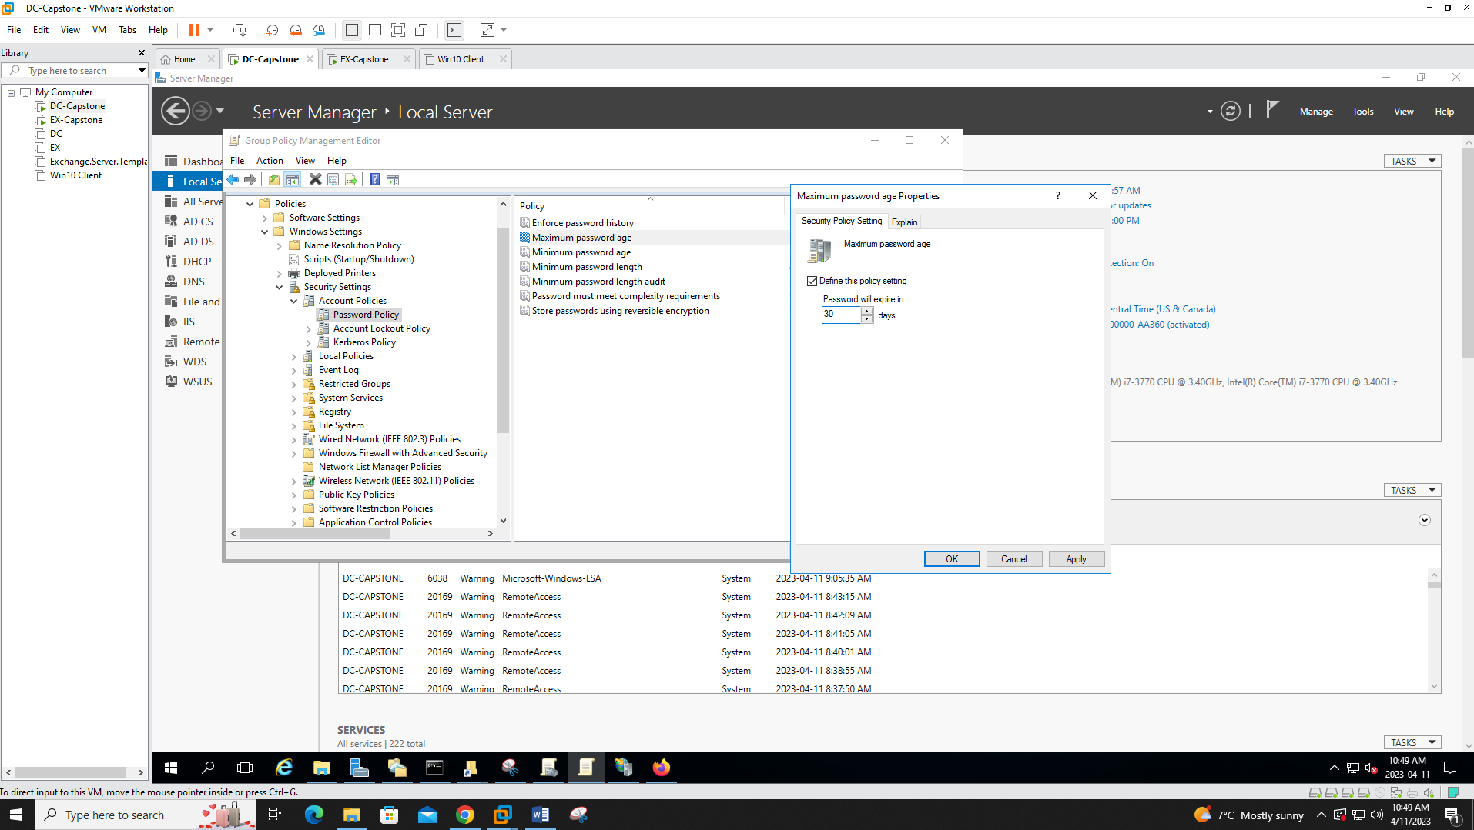

1. **Link all OU to the Dites Group Policy Object**